Lab 4 + 5 Report
PRACTICE QUESTIONS:
1) How do you declare an empty list in Dart?
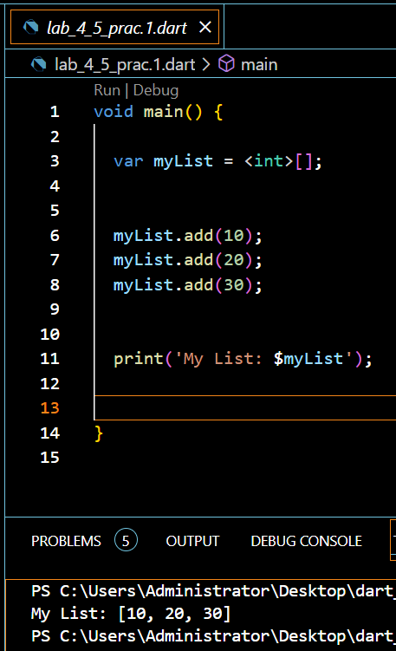
2) How do you access elements in a Dart list?
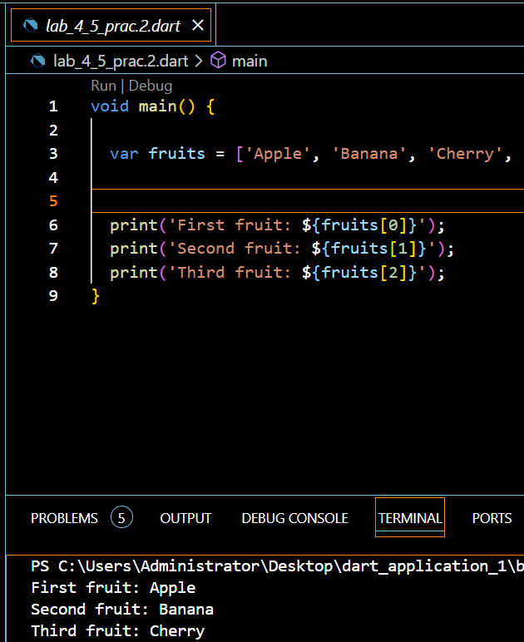
3) Explain how to add an element to the end of a Dart list.
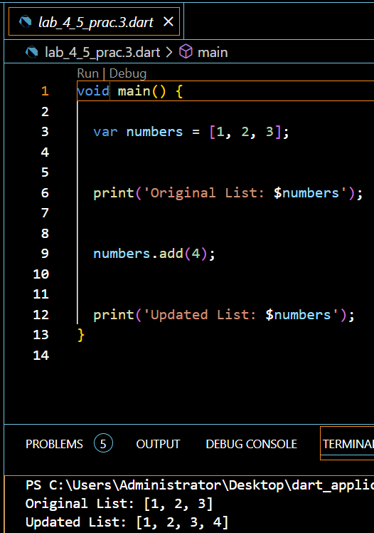
4) How do you remove an element from a specific index in a Dart list?
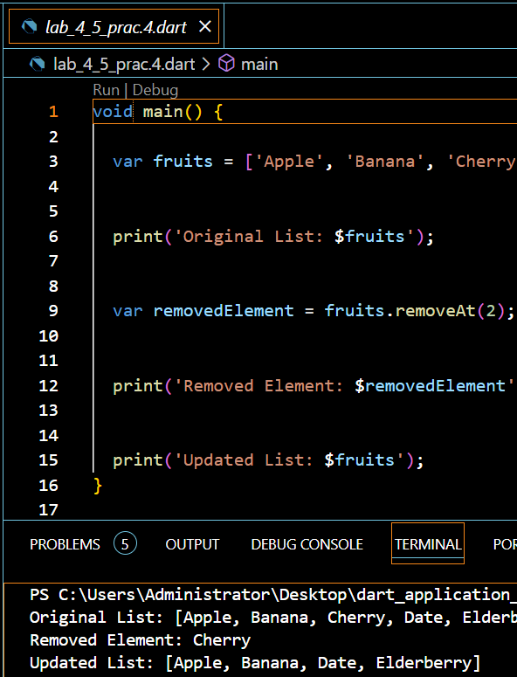
5) What is the length property of a Dart list?
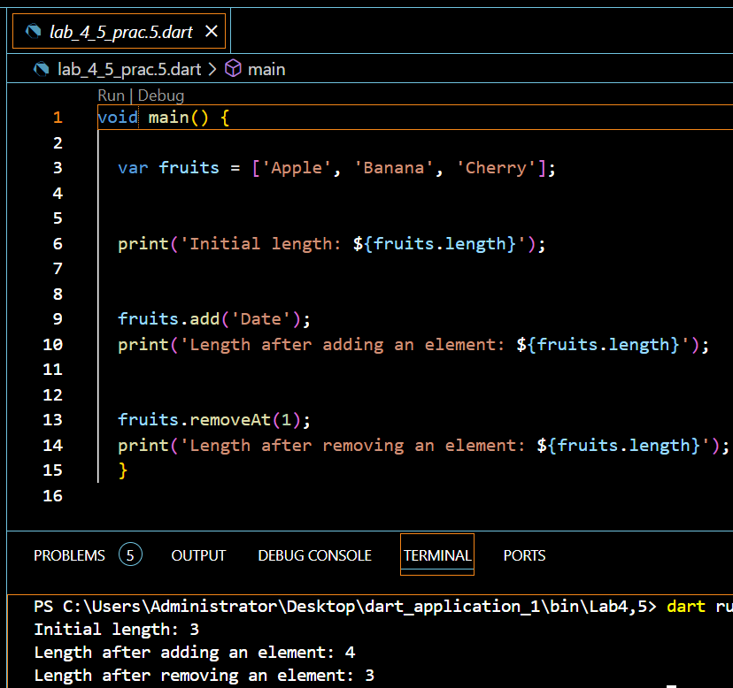
PRACTICE QUESTIONS:
1) How do you declare an empty map in Dart?
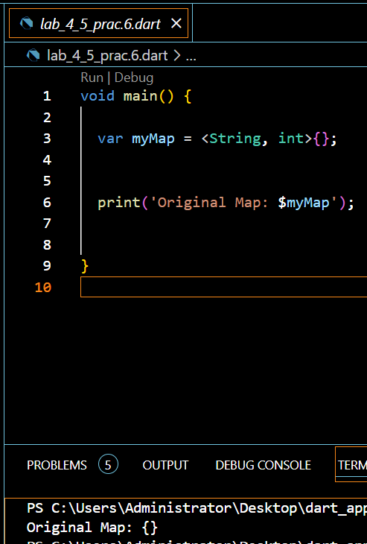
2) Provide an example of initializing a map with key-value pairs.
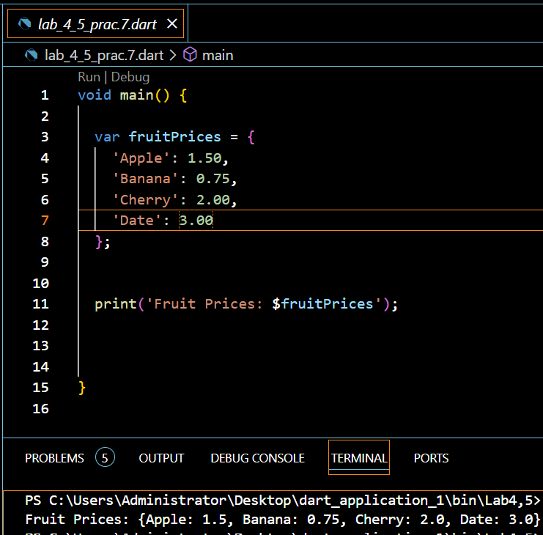
3) How do you access the value associated with a specific key in a Dart map?
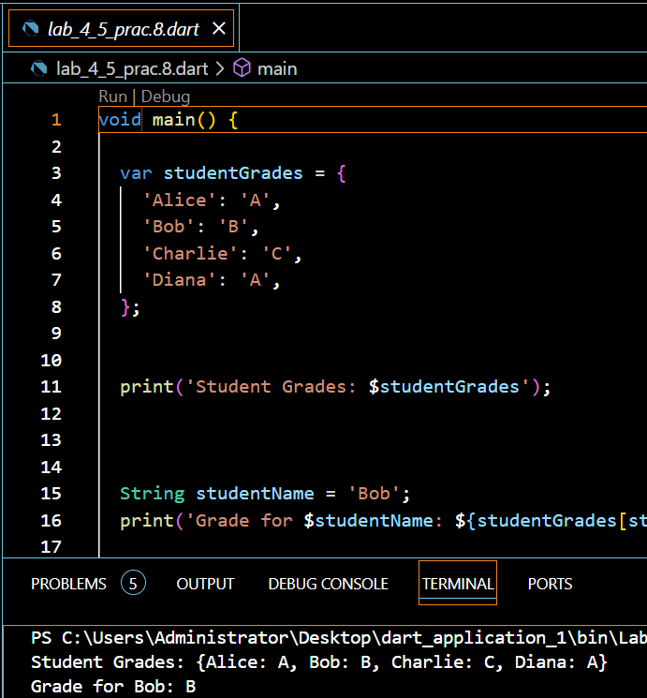
4) Explain how to add a new key-value pair to a Dart map.
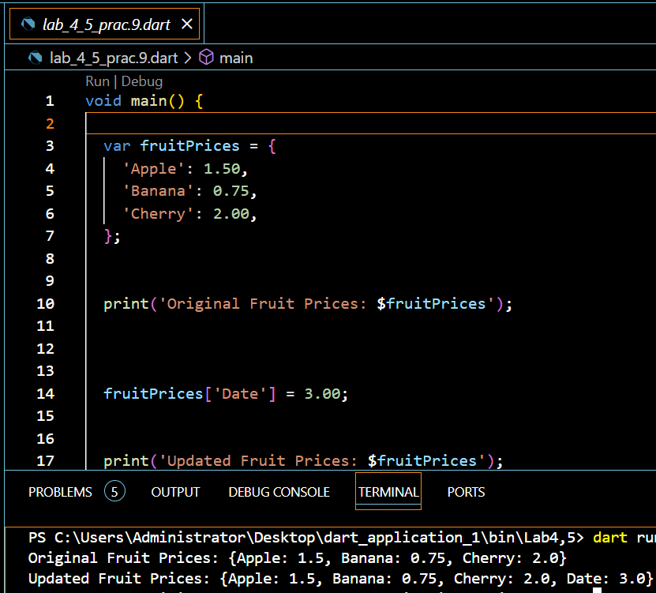

5) What is the length property of a Dart map?
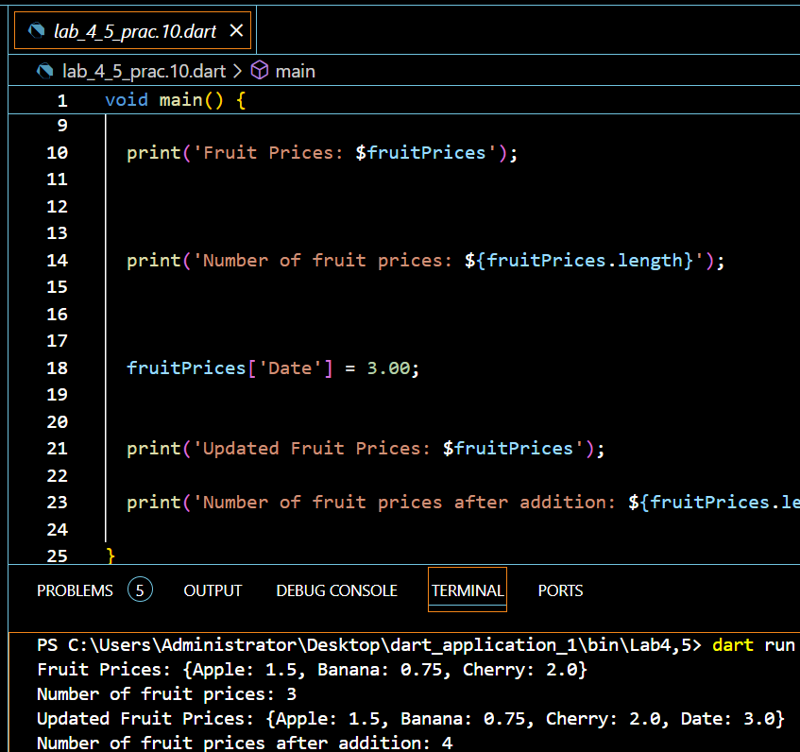
PRACTICE QUESTIONS:
1) Declare two variables, a and b, with values 15 and 7 respectively. Print their sum.
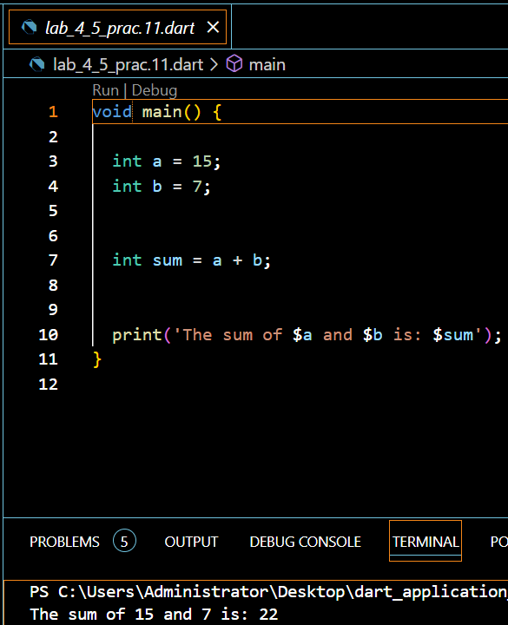
2) Declare two variables, x and y, with values 10.5 and 3.2 respectively. Print their product.
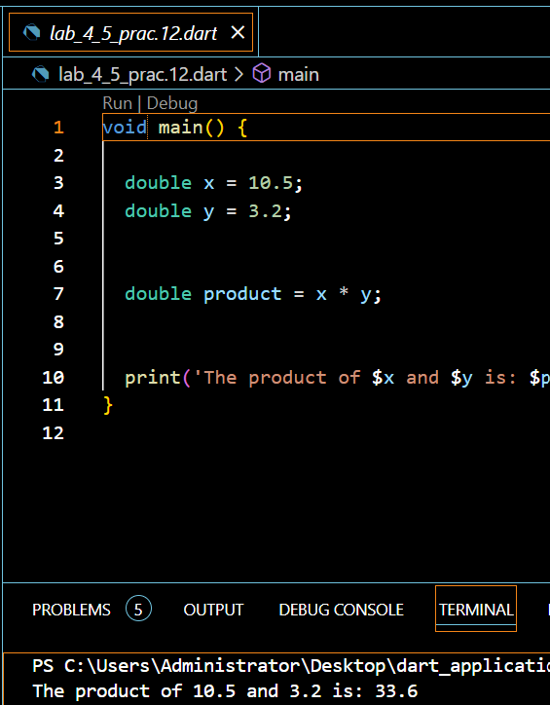
3) Declare a variable num with a value of -8. Print its absolute value.
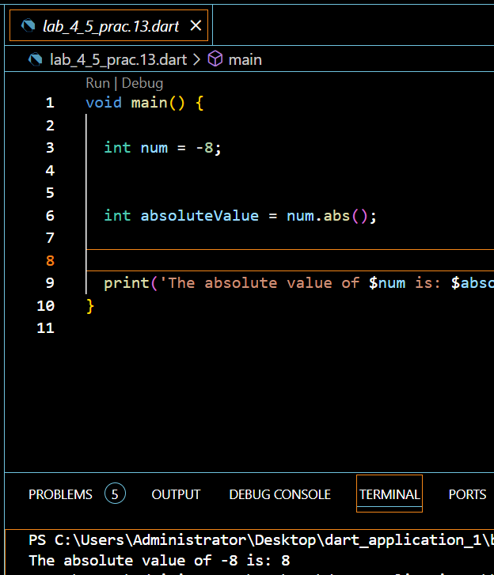
4) Declare a variable decimalNum with a value of 7.3. Print its ceiling and floor values.
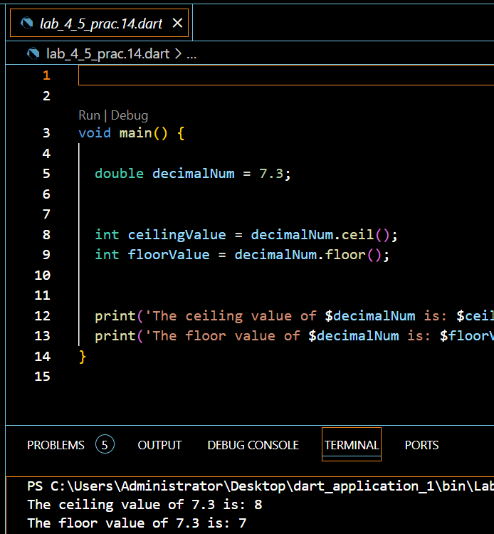
5) Compare the values of a and b. Print whether a is greater than b.
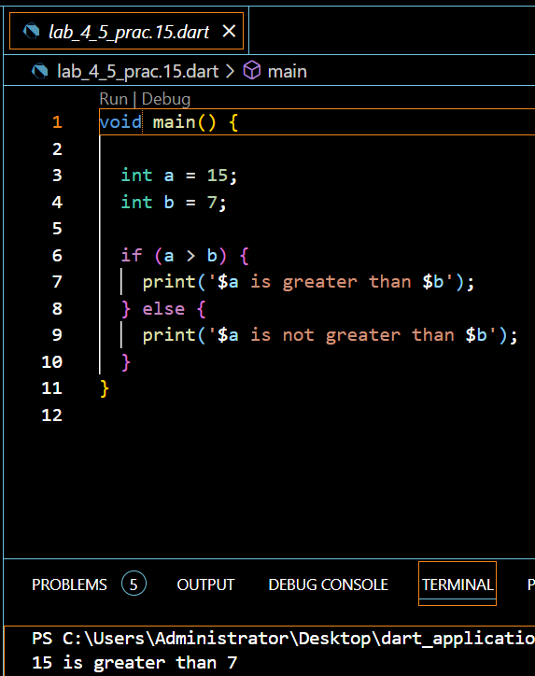
PRACTICE QUESTIONS:
1) Declare an empty set named mySet in Dart.
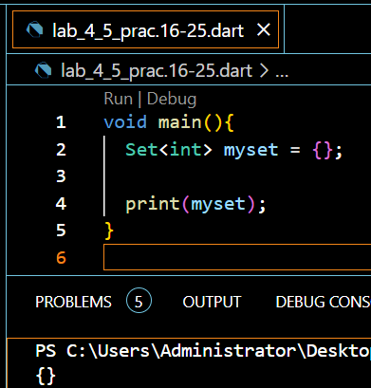
2) Add the numbers 10, 20, and 30 to the set.
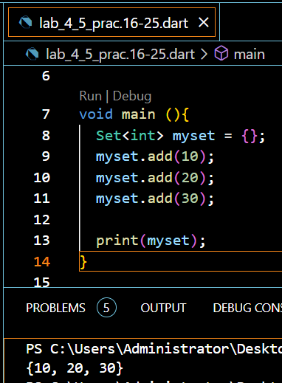
3) Remove the number 20 from the set.
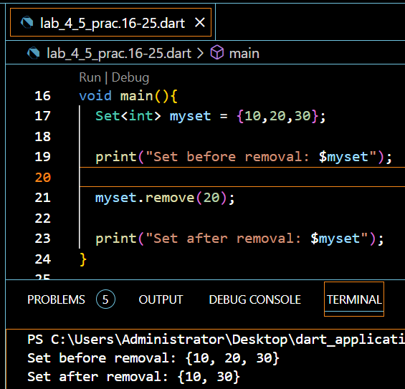
4) Check if the set contains the number 15.
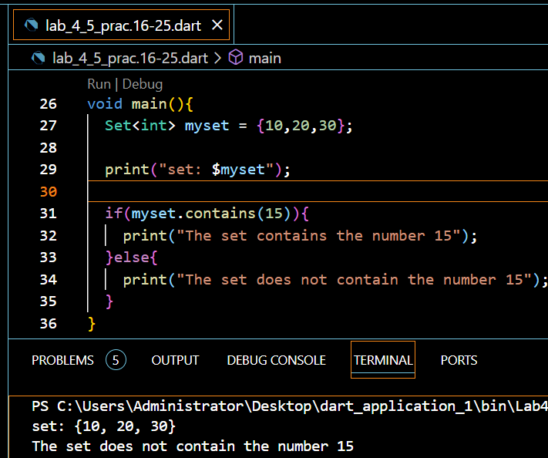
5) Create another set named otherSet with numbers 20, 30, and 40.
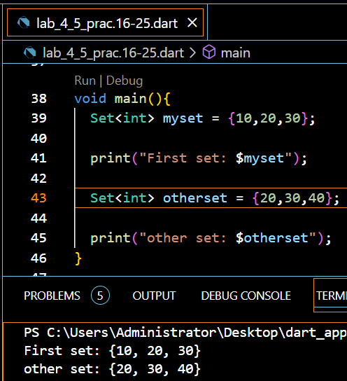
6) Find the union of mySet and otherSet.
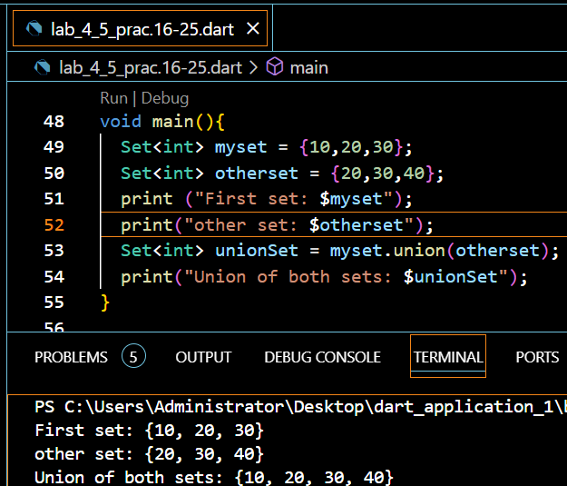
7) Find the intersection of mySet and otherSet.
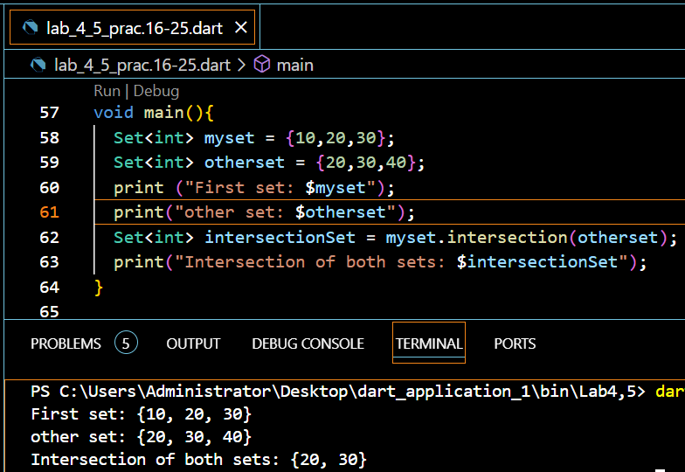
8) Find the difference between mySet and otherSet.
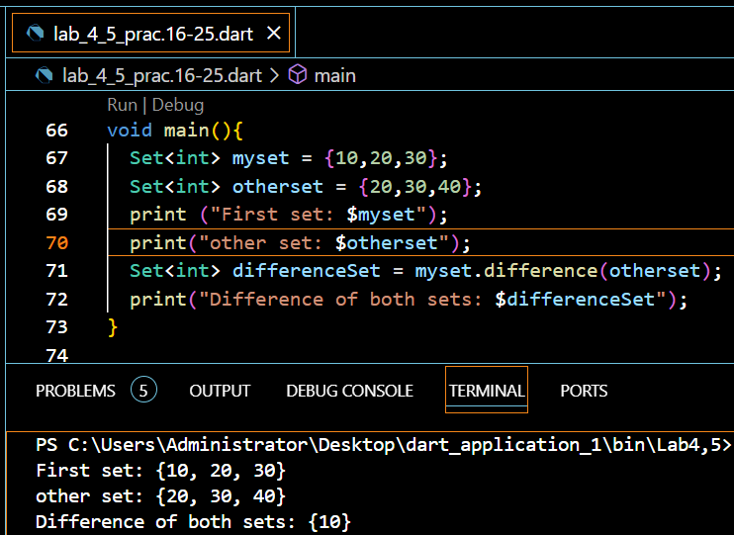
9) Print each element in mySet using a forEach() method.
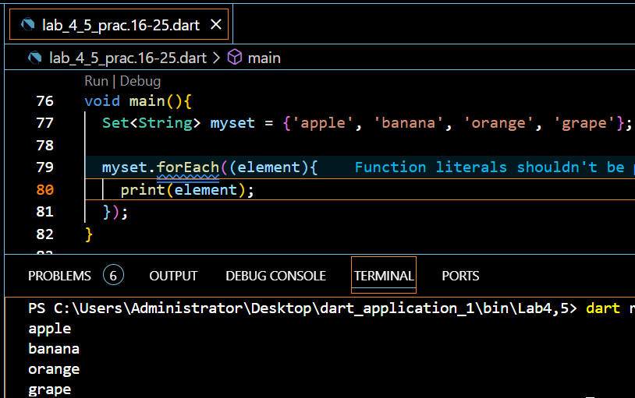
10) Consider a set of unique employee names in a company. Create a Dart program that performs the following tasks:
a. Initialize a set named employeeSet with at least three unique employee names.
b. Convert the set to a list named employeeList.
c. Convert the set to a map named employeeMap where the employee names are used as keys, and their corresponding employee IDs (IDs can be arbitrary) are used as values.
d. Print the original set, the converted list, and the converted map.
